Thesis Lab 1

Unknown currently
- Measure / check what the diameter of the sample-rings are, surface area is critical M
- Doublecheck whether there is enough acetic acid and H₂SO₄ in the lap
- Coordinate with Lab-techs around TAN and soil pH analysis’, I ideally want to be present (perhaps even do them myself after a demonstration) as well
? Where is the soil used for the packed samples stored M
? Is the system set up such that the valve number and container number always is the same, i.e. valve 15 are connected to container 15, or is there another order. M
? Are ammonium carbonate and starch (used in the standards) stored in the lab, what are typical concentrations of either M
? What is the volume typically used in the acid trap M
? How deep is the scratch soil marks typically M
? How often is the dryer chamber exchanged - is it something I should do before starting the experiment M
? How much slurry is required for triplicate TAN analysis of each treatment - should we store some extra, long term

Setup Sketch (as far as I remember)
To convert into flux, sum of the bypass and sample flow
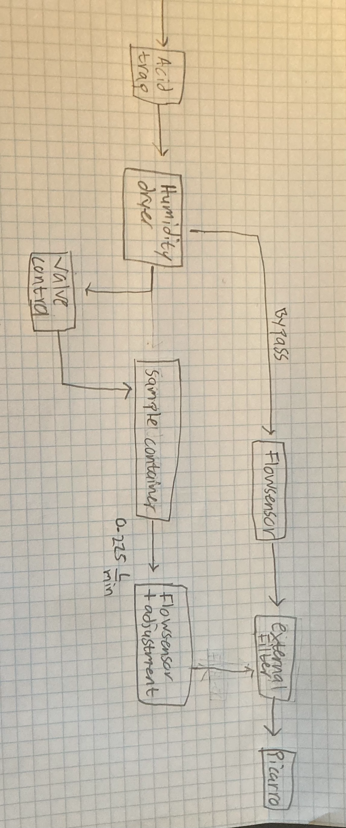

Description
- Cattle-slurry with packed soil and soil collected on the day of the field experiment
- 3 treatments: no acid treatment, acetic acid treatment, and sulphuric acid treatment
- 18 samples in total
- Plus 2 standards using ammonium carbonate

Sample Names
Samples collected on field experiment day = F
Samples with packed soil = P
Standards = S (No treatment)

Untreated = U
Acetic acid = AA
Sulphuric acid = H₂SO₄

Ie. For example, soil sample connected to valve 18, which is untreated packed soil = 18.P.U

Day -2: Get soil data

? Same for agro soil
…

Measure Dry-mass content in field soil-samples
Attain 3 of own soil samples from storage
Same procedure for measuring DM as with fields in L32:
- Measure mass of aluminum-container
- Dump soil into container, measure container + soil
- Dry in oven for 24 hours, measure mass afterwards

- Check here whether red plastic lids can be removed easily.

? Also take out samples for soil pH?

Day -1 Prepare soils, setup, and acidify slurry
Acid-trap
needs to be refilled 0.05 M H₂SO₄
? I think 1 L is needed
$$C_{1}V_{1}=C_{2}V_{2}$$
V₂ is only unknown
$$V_{2}=V_{1}+V_{water}$$
$$C_{2}=0.05 M$$

If using is 95 %Wt. H₂SO₄:
$$ρ_{solution}=1.88337 g mL^{-1}$$
For 1000 mL
$$m_{solution}=1883.37 g$$
$$m_{H2SO4}=1883 g·0.95=1789.20 g$$
$$n_{H2SO4 }=\frac{1789.20 g}{98.079 g mol^{-1}}=18.24\frac{mol}{L}=C_{1}$$

Packed soils
? Where is the soil stored
Sieve the soil at the biogas plant
- Break clumps of dirt left behind
- Mix with (gloved) hand afterwards
Get special stamps from Agro
Determine how much water to add
- average gravimetric water content for cattle-soil were:
$$u_{cattle}=0.17\frac{g_{water}}{g_{soil}}$$
$$u_{add}=u_{cattle}-u_{current}$$
? How much is g_{soil}, the samples are packed to uniform density, but I can’t remember how much
$$m_{water add}=u_{add}·g_{soil}$$
As the soils are packed 4 times:
$$\frac{m_{water, add }}{4}=…$$
Use milli-Q water!
Add the water as droplets using a pipette
How much soil to add each time
Pack the soil 4 times (largest to smallest piston!):
$$\frac{g_{soil}}{4}=…$$
Scrath the surface
? Between each packing, add water and disturb the surface with a fork $≈2 mm depth$
Create a line in the center, then turn the sample, remember to
Set aside for next day
When packed, enclose the samples with plastic-wrap, find 9 petri dishes and store them close
Make a dummy to check if red lid is easily exchanged with petri dish

Field soil-samples
Take own soil samples from refrigerated storage into lab, find and number 9 samples (3 untreated = U, 3 AA, 3 H₂SO₄)
cover these with plastic wrap and keep them in in the lab overnight so the experiment can quickly get started the next day. Find 9 petri dishes for these and store them close

Acidify slurry
How much slurry to use:
If we use 2 g = 2 mL per sample, with 18 samples: $≥36 mL$ , in 3 containers
? How much extra for TAN analysis
H₂SO₄
? For H₂SO₄, if the goal is to match the same application rate as the field trial
- Measure pH before acidifying
- Add this amount while stirring, measure pH after 1 min
$$\frac{0.18 kg_{acid}}{60.05·{10}^{-3} t_{slurry}}=\frac{2.9975·kg_{acid}}{t_{slurry}}$$
AA
For AA, add 0.1 mL and measure pH 1 min after each time until same pH level is reached.
- Note amount of AA used, note pH-level - triplicates!
Store slurries in enclosed containers until next day.
prepare pure ammonium carbonate sample
? Where is ammonium carbonate and starch (increase viscosity) kept
? what were typical concentrations for these
Store in lab fridge

Prepare Picarro
Start the pump, quickly check whether the flows are reasonable
Change Any Desk code into “Windtunnel”
Setup measuring-cycle for a full experiment requiring all valves, if this is not already done

Day 1 - start of experiment, car is needed

Start the pump and ensure stable flow
- Ensure all sample-flows are 0.225 L/min, before experimental start
- Ensure valve-shifts work as intended
- Note time-delay between picaro and actual time

Measure pH
For all 3 types of slurries before the start of the experiment - triplicates!

Start the experiment, prepare current sample
Approx 2-3 min before valve shift, remove plastic-wrap from current sample
Add 2 g of needed slurry as drops, in small as droplets
Exchange red plastic lid, with petri-dish
Add to Picarro setup
Note picaro-time for the shift, and the flow of the sample stream, and bypass

Day 2-6 During experiment
Download yesterday’s raw Picarro file into own folder via Any Desk
Repeat for next day

Day 7 End of Experiment
Note Picarro-time for the end of the experiment.
Download raw Picarro file for the final day.
Note bypass and sample flows, is expected to have a slight decrease - an average between start and end will be used.
Remove the samples from the setup, can most likely dilute and put into sink.

